Project Title:
PSADT DEPLOYMENTS ON vM & running/modifying script based on requirement.

Created By:-
Krishna Verma
User id- 34851
Email - kv979539g@gmail.com

Project Overview :
The goal of our project is to learn how to create, test, and modify a software deployment package using the PowerShell App Deployment Toolkit (PSADT). We will focus on creating a wrapper for a standard application installer (such as an .msi file), testing its functionality on a virtual machine (VM), and understanding how to modify the script to meet specific requirements.

Key Concepts :
- PowerShell App Deployment Toolkit (PSADT): It is an open-source framework that standardizes the process of deploying Windows applications. It provides a robust, pre-built PowerShell script and a set of functions to handle common deployment tasks.
- Wrapper: A script that "wraps" around an application's native installer, providing additional functionality like user prompts, custom actions (e.g., creating a file or registry key), and detailed logging.
- Virtual Machine (VM): An essential tool for testing. A VM allows you to simulate a clean, real-world user environment without affecting your primary operating system.

Objectives :
- Automate the deployment of applications using PSADT.
- Provide a standardized install/uninstall mechanism.
- Demonstrate deployment in a controlled VM environment.
- Generate logs and registry keys for auditing.
- Gain hands-on experience in scripting and using PSADT.

Project Requirements :
- Windows 10/11 Virtual Machine
- PowerShell 5.1 or later
- PowerShell App Deployment Toolkit (PSADT)
- Application installer (MSI/EXE of our choice)
- Text Editor (VS Code / PowerShell ISE/ Notepad)
- Admin privileges on the VM

Architecture Diagram :
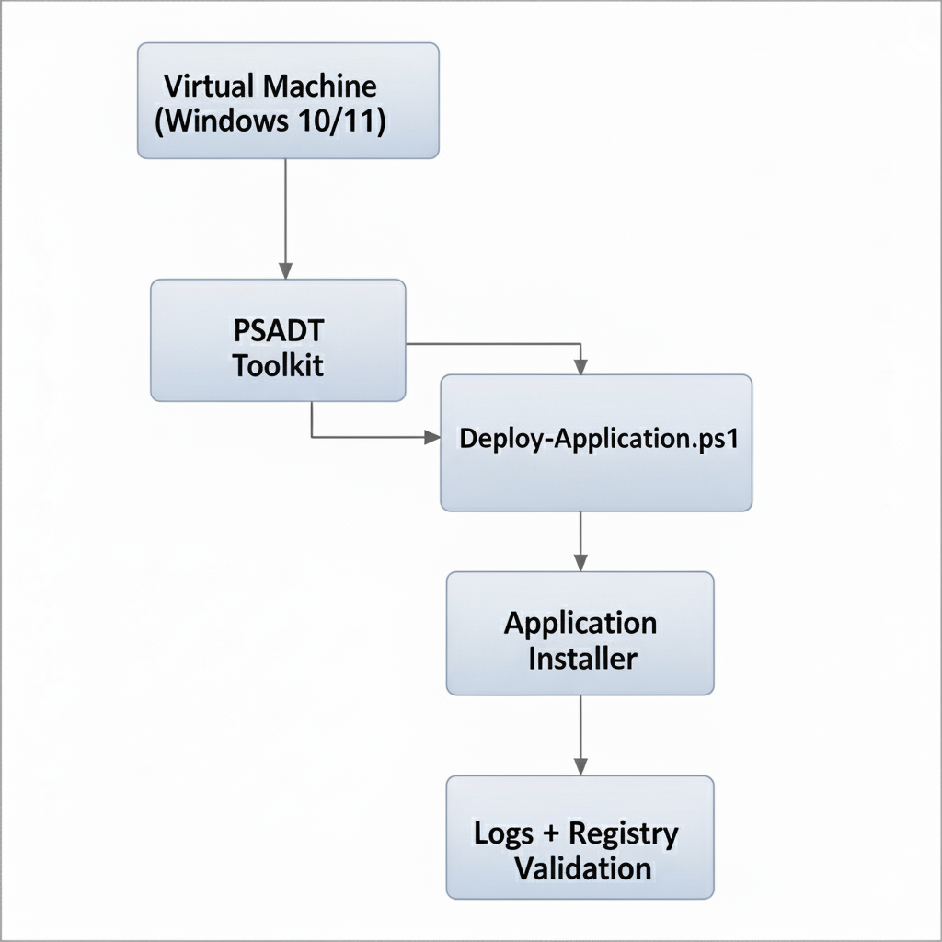

Execution Overview :
Step 1: Initial Setup
- Download PSADT
The first step is to download the latest version of the PSADT from its official GitHub repository.
- Go to the PSADT GitHub Releases page and download the .zip file for the latest release.
- Extract the contents of the .zip file to a new, dedicated folder. This extracted folder will be our project's root directory. The most important files are Deploy-Application.ps1 and AppDeployToolkitMain.ps1.
Step 2: Set up the Project Folder
Within the extracted PSADT folder, we will find a Files folder. This is where we will place the application installer that we want to deploy.
- Example: For our project, we use a sample application installer. Download the 64-bit MSI for 7-Zip and place it inside the Files folder.
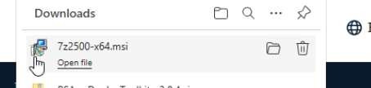
Our project structure should look something like this:
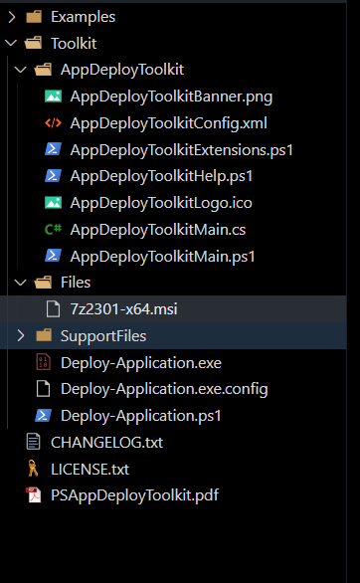
Step 3: Prepare the Virtual Machine
- Set up a clean VM running Windows 10 or 11.
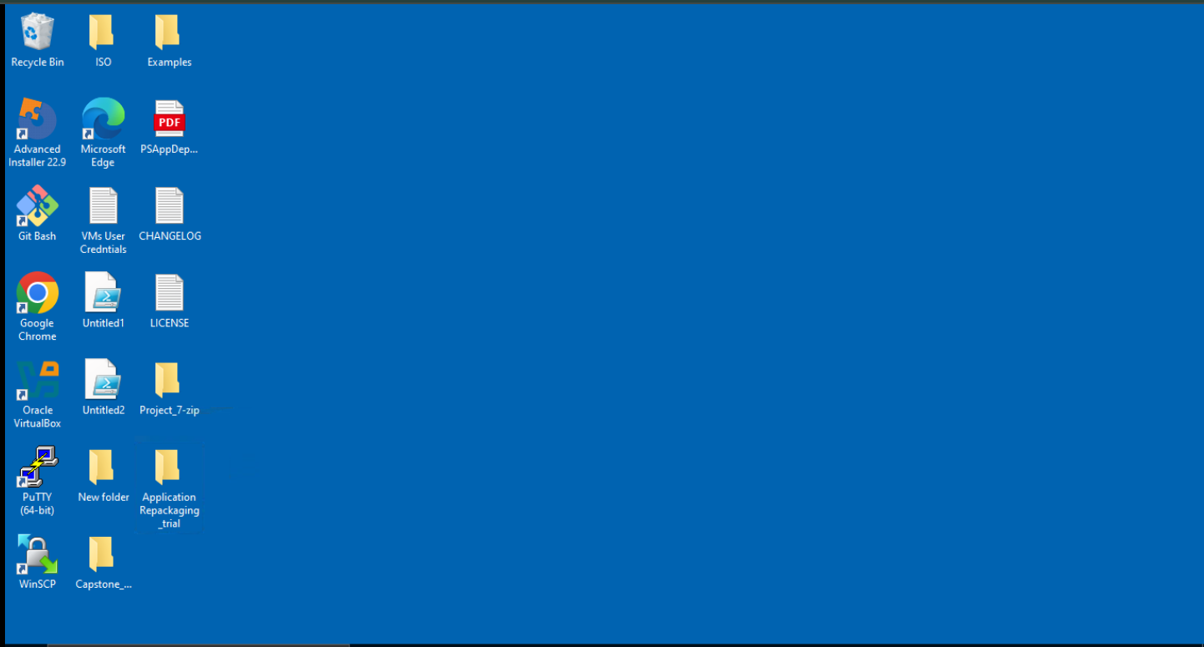
- Ensure PowerShell is updated to at least version 5.0.
Step 4: Modifying the PSADT Script (Deploy-Application.ps1)
The Deploy-Application.ps1 script is the main file we will modify. It's pre-populated with comments and examples to take as a reference guide. We will work within specific sections of this script.
a. Fill Out Application Details :
At the top of the script, we will find a "Variable Declaration" section. We have to fill the details of the application that we need to deploy.
## VARIABLE DECLARATION
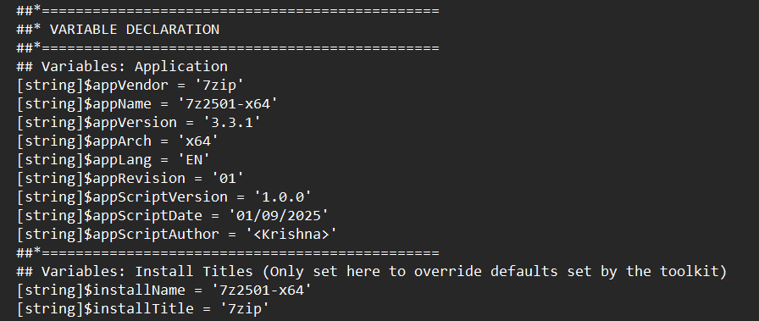
b. Add Installation Logic :
Scroll down to the Installation section. This is where we will add the commands to install our application. The PSADT framework provides a function specifically for MSI installers: Execute-MSI.
## Pre-Installation
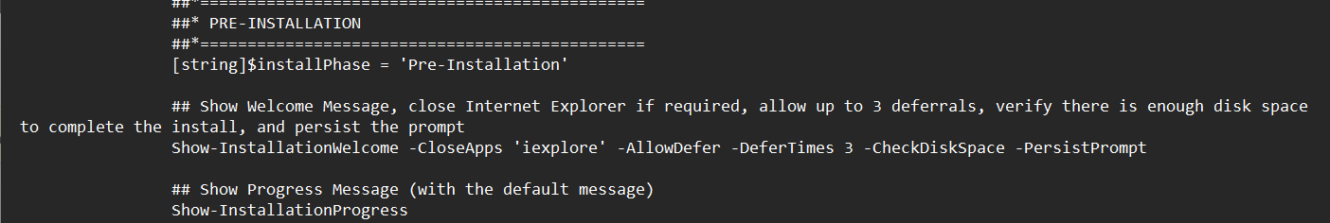
## Installation
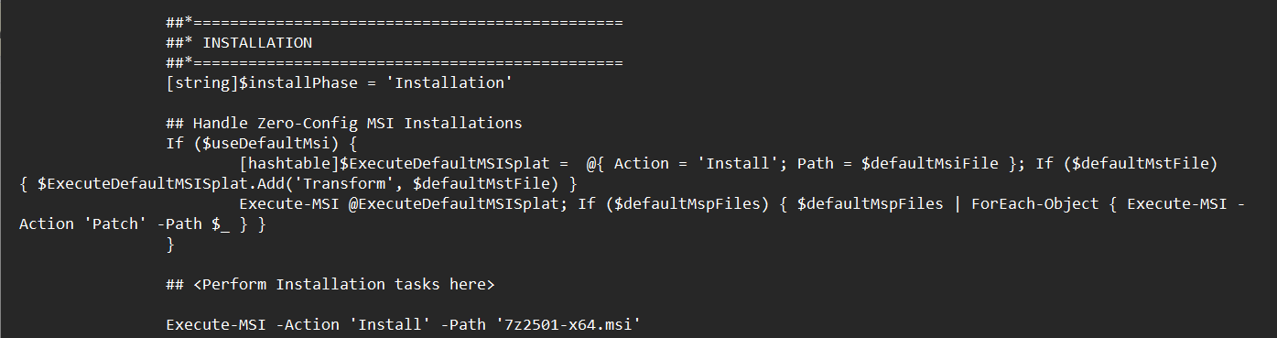
## Post-Installation
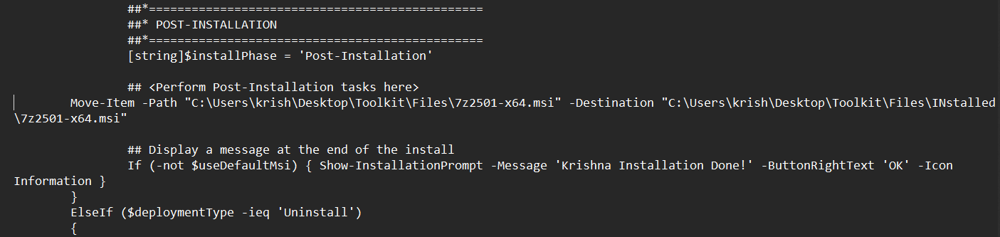
c. Add Uninstallation Logic :
Scroll to the Uninstallation section. It's just as important to define how the application is removed. You will use the Execute-MSI function with the Uninstall action. The script can automatically find the MSI by its product code, or you can specify the MSI name as we did for the installation.
## Pre-Uninstallation
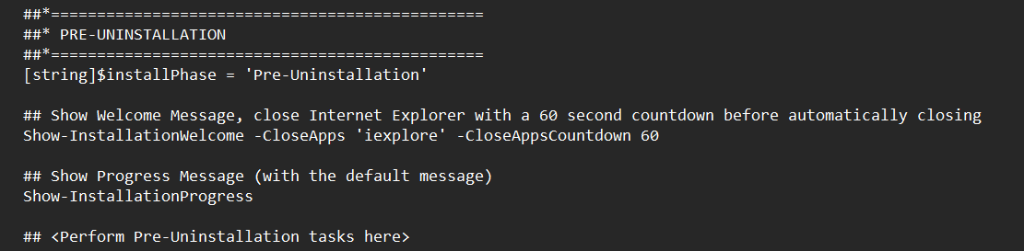
## Uninstallation
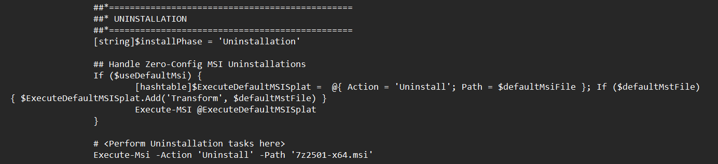
## Post-Uninstallation
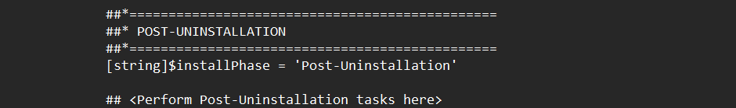
Step 5 – Run Deployment :-
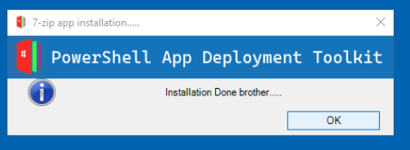
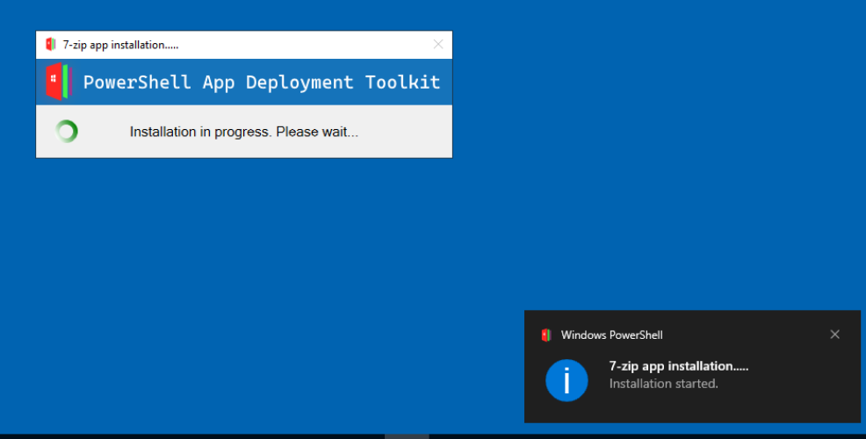
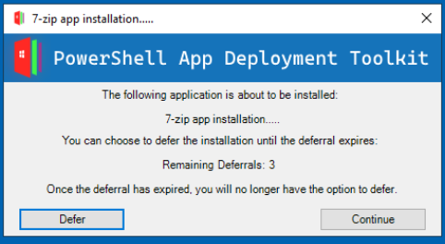
Installation :
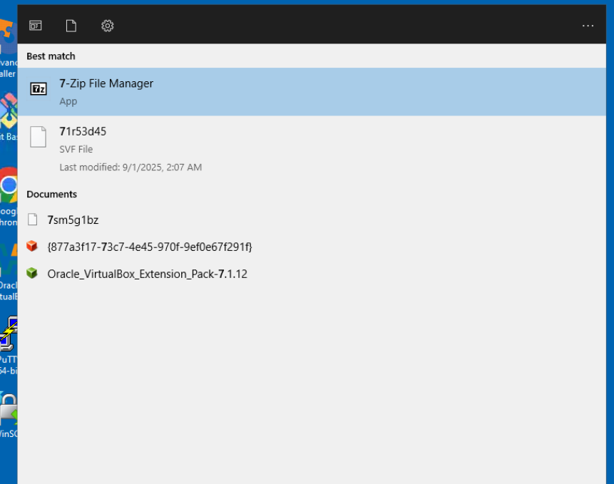

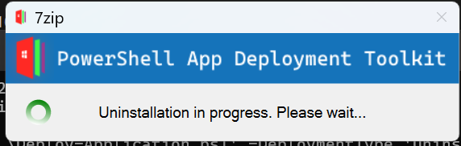
Uninstallation :-

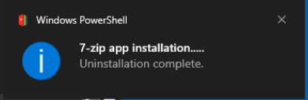

Modifying Script :-
- We need to move folder after installation into another folder.
- Then we need to modify the Post installation script.
- In this task me moved our installer .msi file into a new folder during the post installation phase.
- The Script was like that in post-installation section:
Move-Item -Path “” -Destination “” -Force
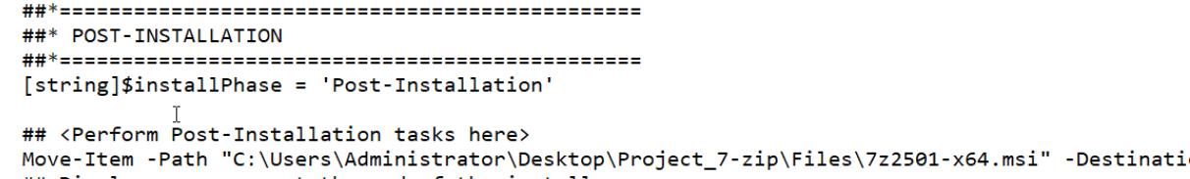
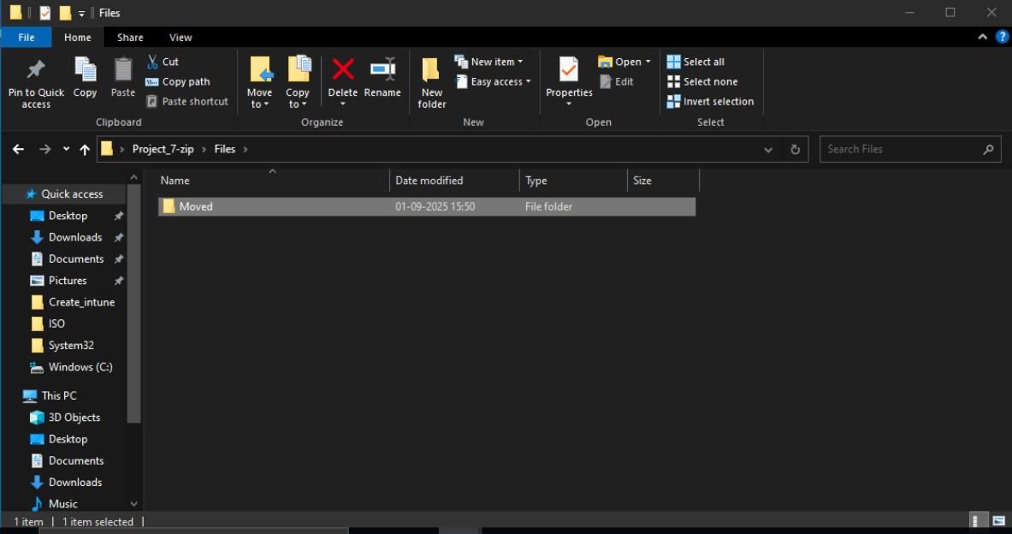
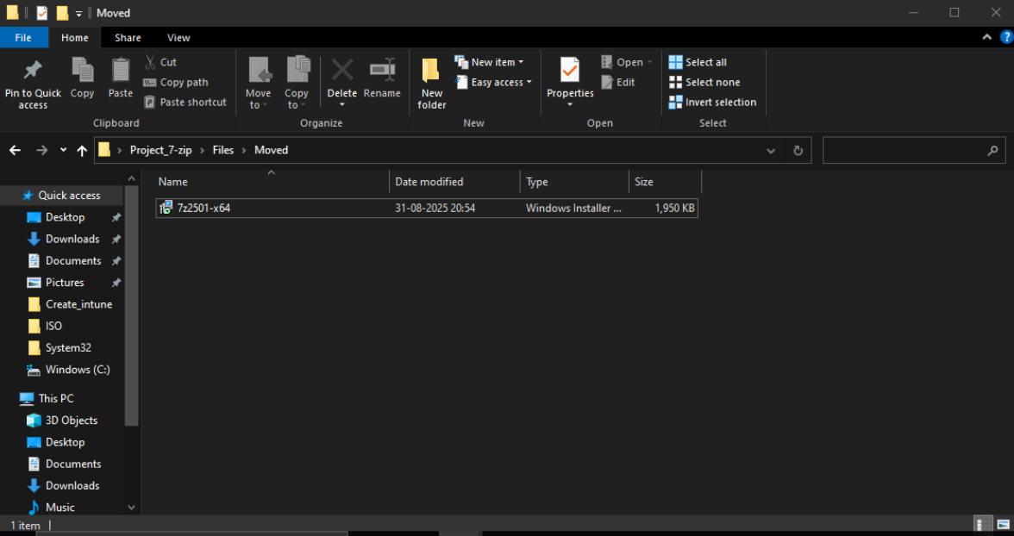

Verifying results through logs and registry :-
1. Logs :
- Check PSADT logs at:
C:\Windows\Logs\Software or AppDeployToolkit\Logs
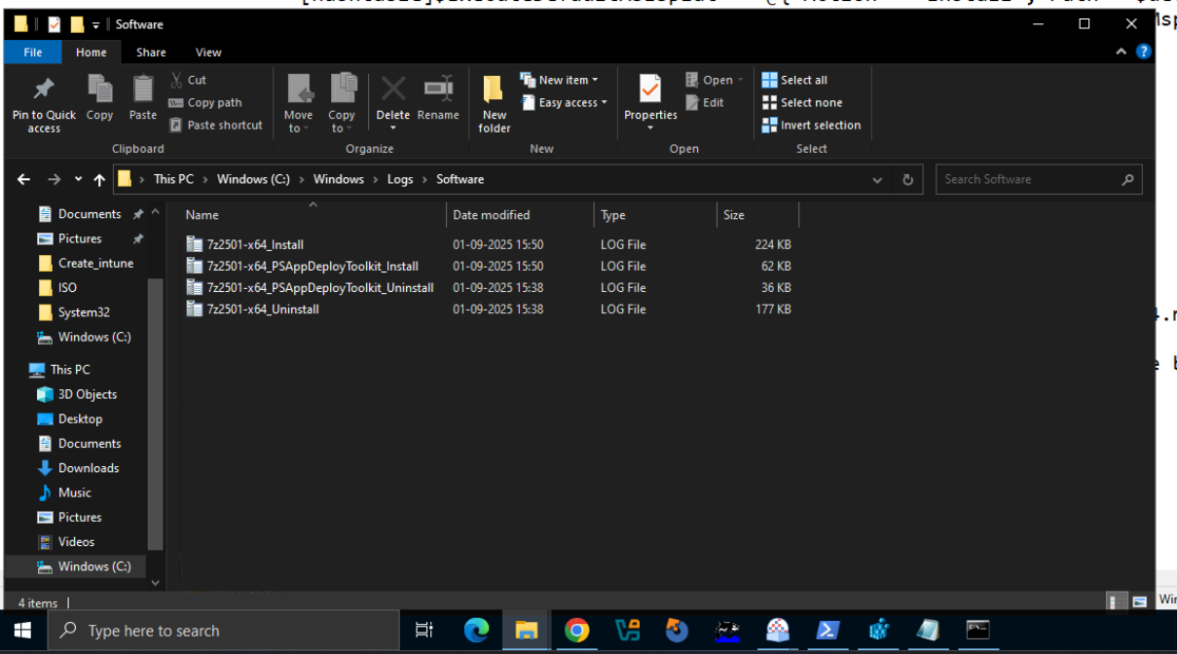
- Confirm installation success message.
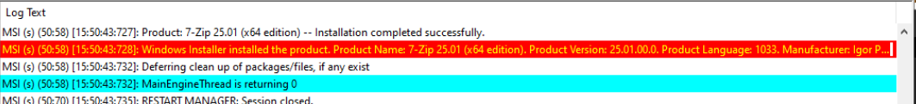
2. Registry :
- Open regedit → Navigate to:
HKEY_LOCAL_MACHINE\SOFTWARE\Microsoft\Windows\CurrentVersion\Uninstall
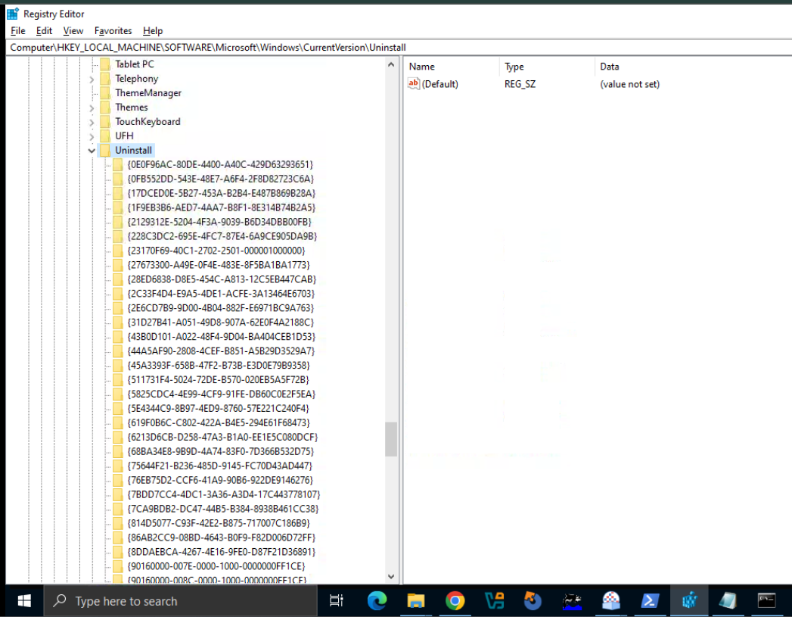
- Verify product entry is present (7-Zip or chosen app).
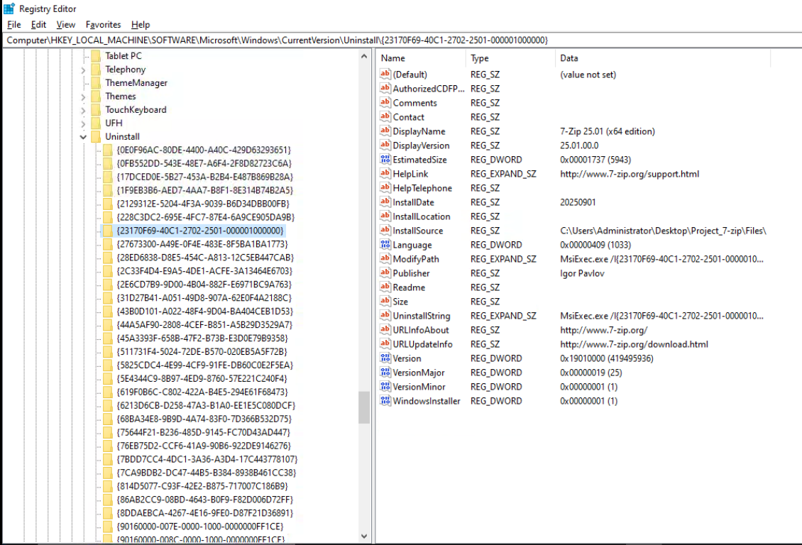
Hence, Installation verification was successful.

Technologies / Tools Used :
- PowerShell 5.1+: Automation scripting.
- PowerShell App Deployment Toolkit (PSADT): Deployment framework.
- Target Application Installer (MSI/EXE): Chosen app for deployment.
- Virtual Machine (VMware / VirtualBox / Hyper-V): Testing environment.
- Windows Event Viewer & Logs: For analysis.
Tasks Performed :
- Setup of VM environment.
- Downloaded and configured PSADT.
- Structured project folders.
- Customized deployment script for application.
- Executed install / uninstall /modification.
- Validated results through logs and registry.
- Documented complete process with screenshots.
Conclusion :
The project successfully demonstrates how to deploy an application using PSADT. The toolkit makes deployments consistent and reliable while providing logging for troubleshooting. By working in a VM, deployments can be tested safely before moving to production.
References :
- PSADT GitHub
- PSADT Docs – PSADT Usage
- Application vendor documentation (7z2501-x64.msi).
- Community blogs on application packaging.

